Visualization 1
In the visualization 1, we set up several parameters to control the view, listed as follows:
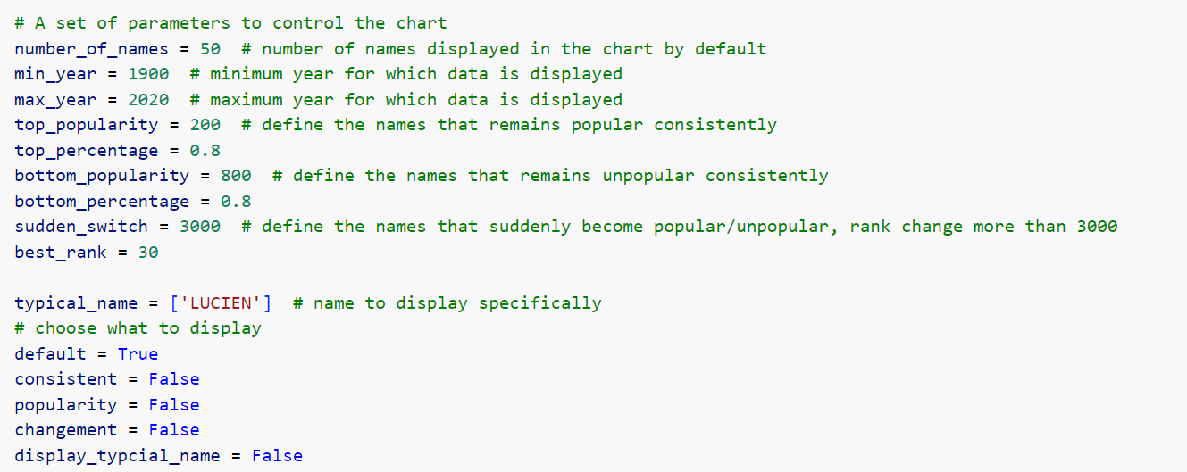
We use some key words (e.g. default, consistent etc.) to decide which view should be displayed and some parameters to filter out the data to fit different needs (e.g. number_of_names, top_popularity etc.). The meaning of each will be explained in detail later.
In the main default graph (when default is set as True and others False) ,The visualization consists of three charts depicting the trends of popular names in France from min_year to max_year.
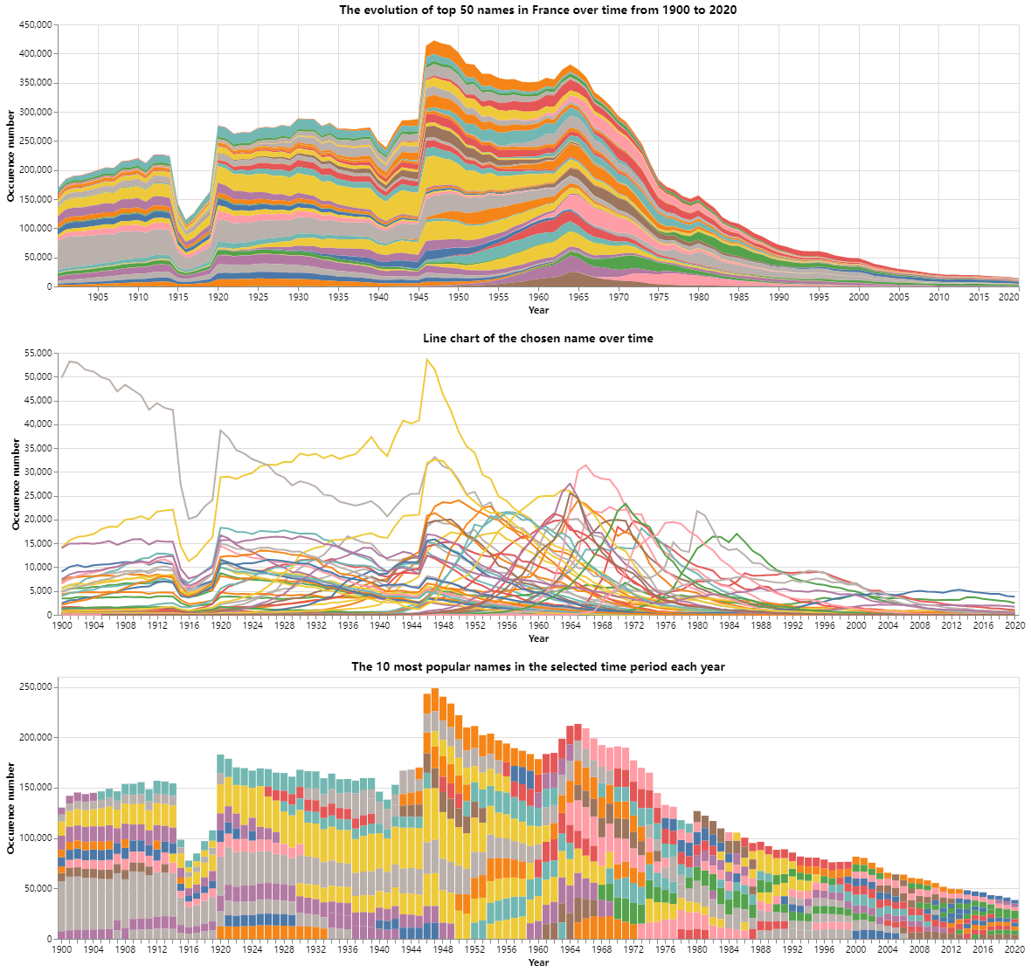
- Top Chart: This area chart shows the evolution of the top 50 names in France over time. Each color band represents a different name, and the width of the band corresponds to the name's popularity, measured by the number of occurrences each year.
- Middle Chart: This line chart displays the trends of individual chosen names over time. Each line represents a different name, showing the number of occurrences per year.
- Bottom Chart: This bar chart highlights the 10 most popular names in each selected time period, with each color representing a different name. The height of the bars reflects the number of occurrences.
We can interactively select a time period and that will vary the time period of the two charts below.
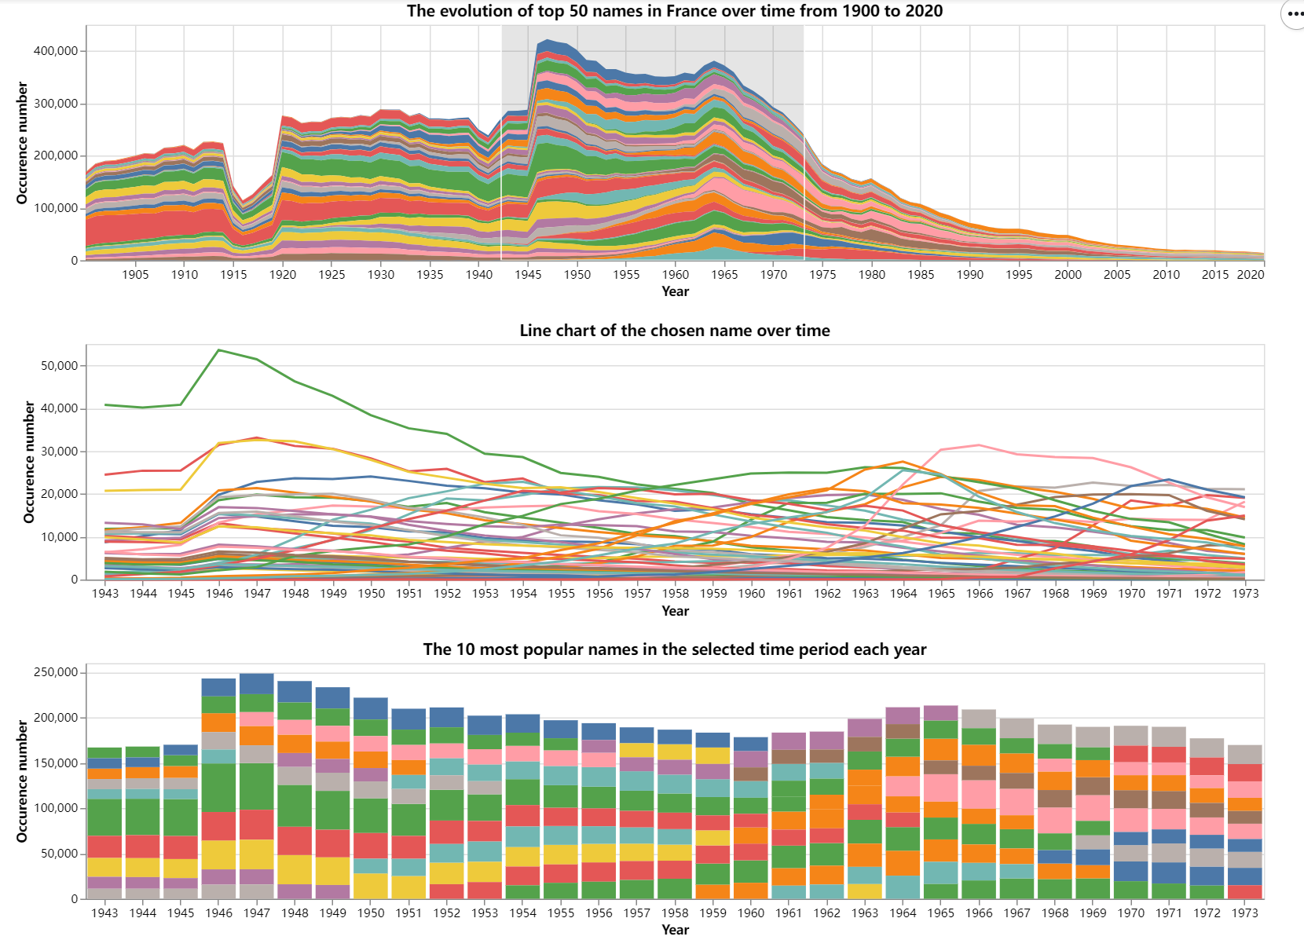
Also we could hover on a typical name to see its evolution over time. We could also choose a typical time period and hover on a typical name at the same time. In this way, we could see how top baby names in France vary with respect to time.
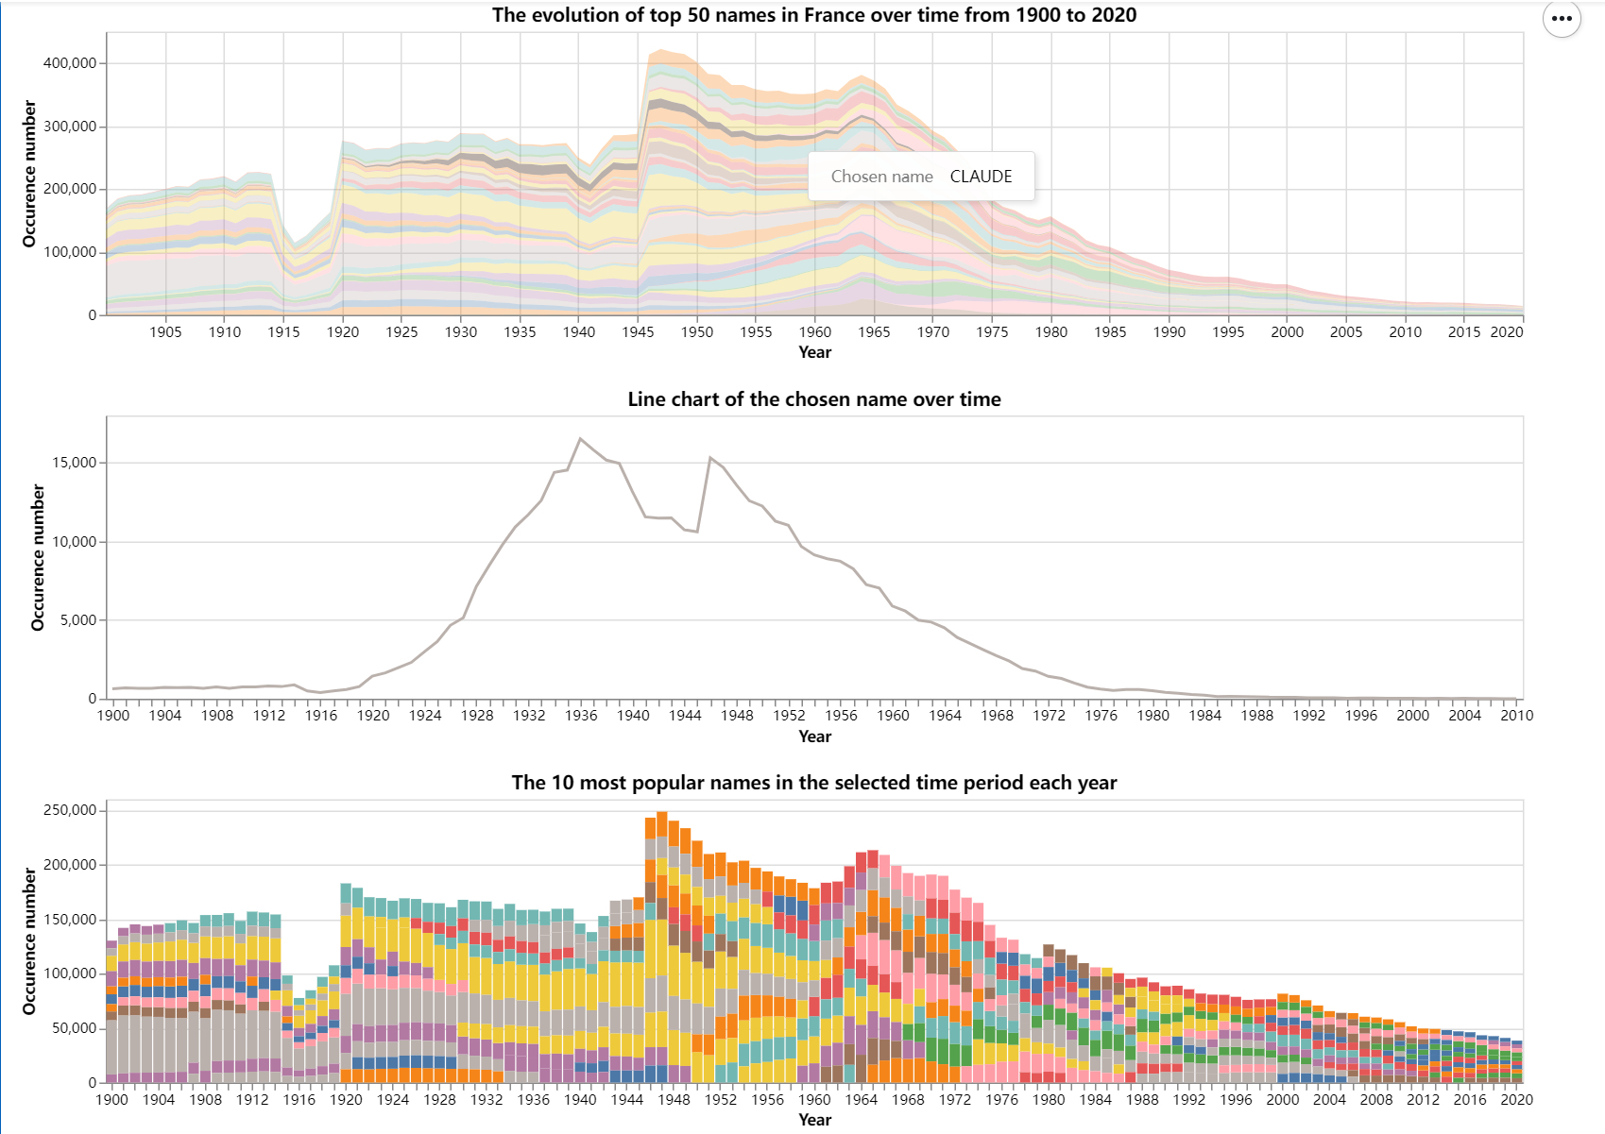
We could hover on the color to see its tag.
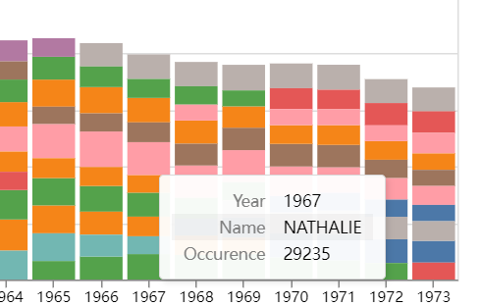
Then if we want to know the evolution of a typical name, we could set display_typical_name = True and set typical_name = ‘xxx’. The following chart shows an example of typical_name = ‘Lucien’.
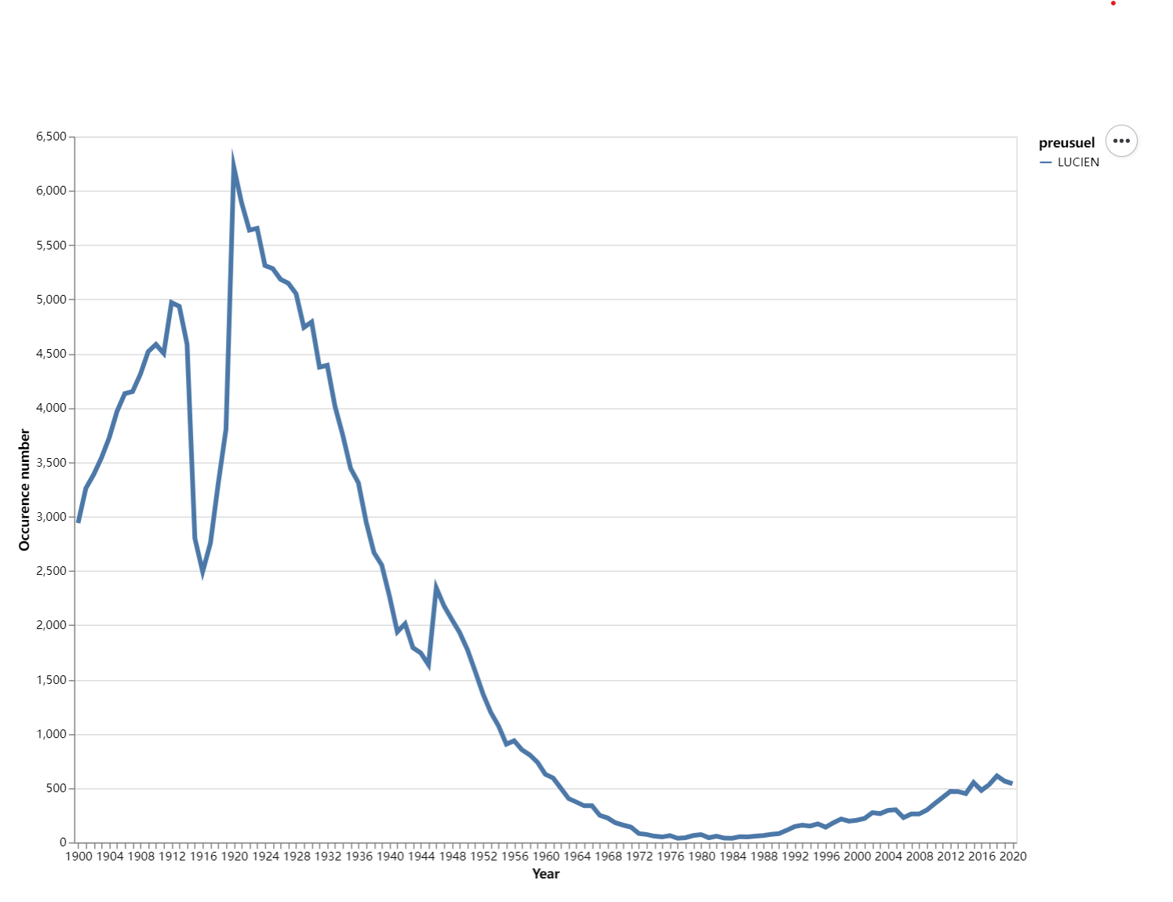
In this way we could see the evolution of every name during a certain time period (min_year, max_year).
Then we set another set of parameters to filter out the consistent popular/unpopular names. We define consistent popular name as: Those names that remains in top top_popularity (e.g. 200) in top_percentage (e.g. 80%) percent of the year in (min_year, max_year). The chart below shows the filtering result by setting top_popularity = 200 and top_percentage = 80%.
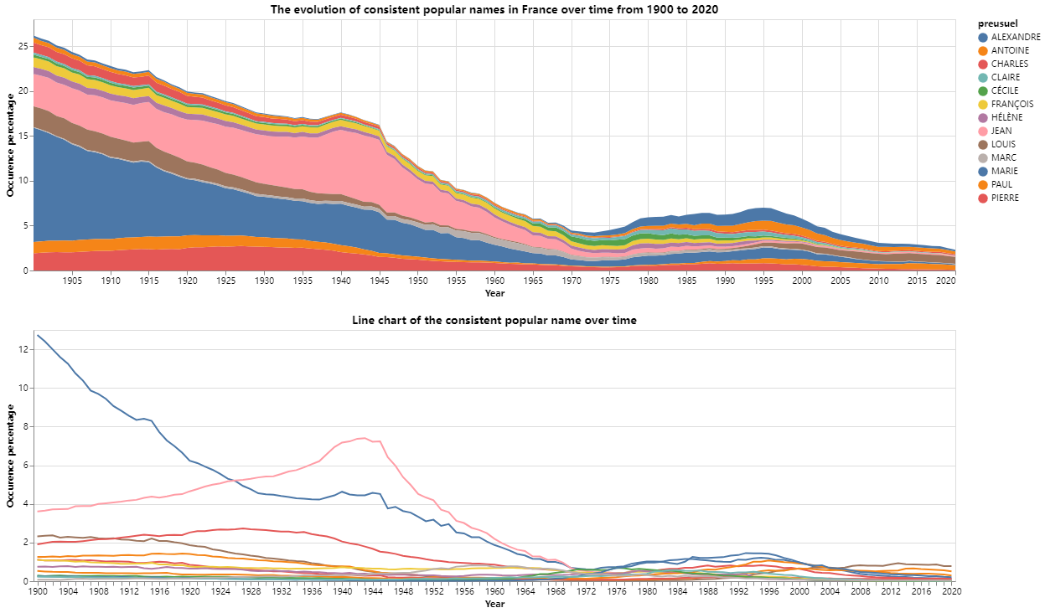
To show the above result, we need to set consistent = True. Same as before, we could select a certain time period or select a typical name to clearly see its trend (figure below). By varying the two parameters, we could set our own definition of “popularity” and filter out the names that fit the condition.
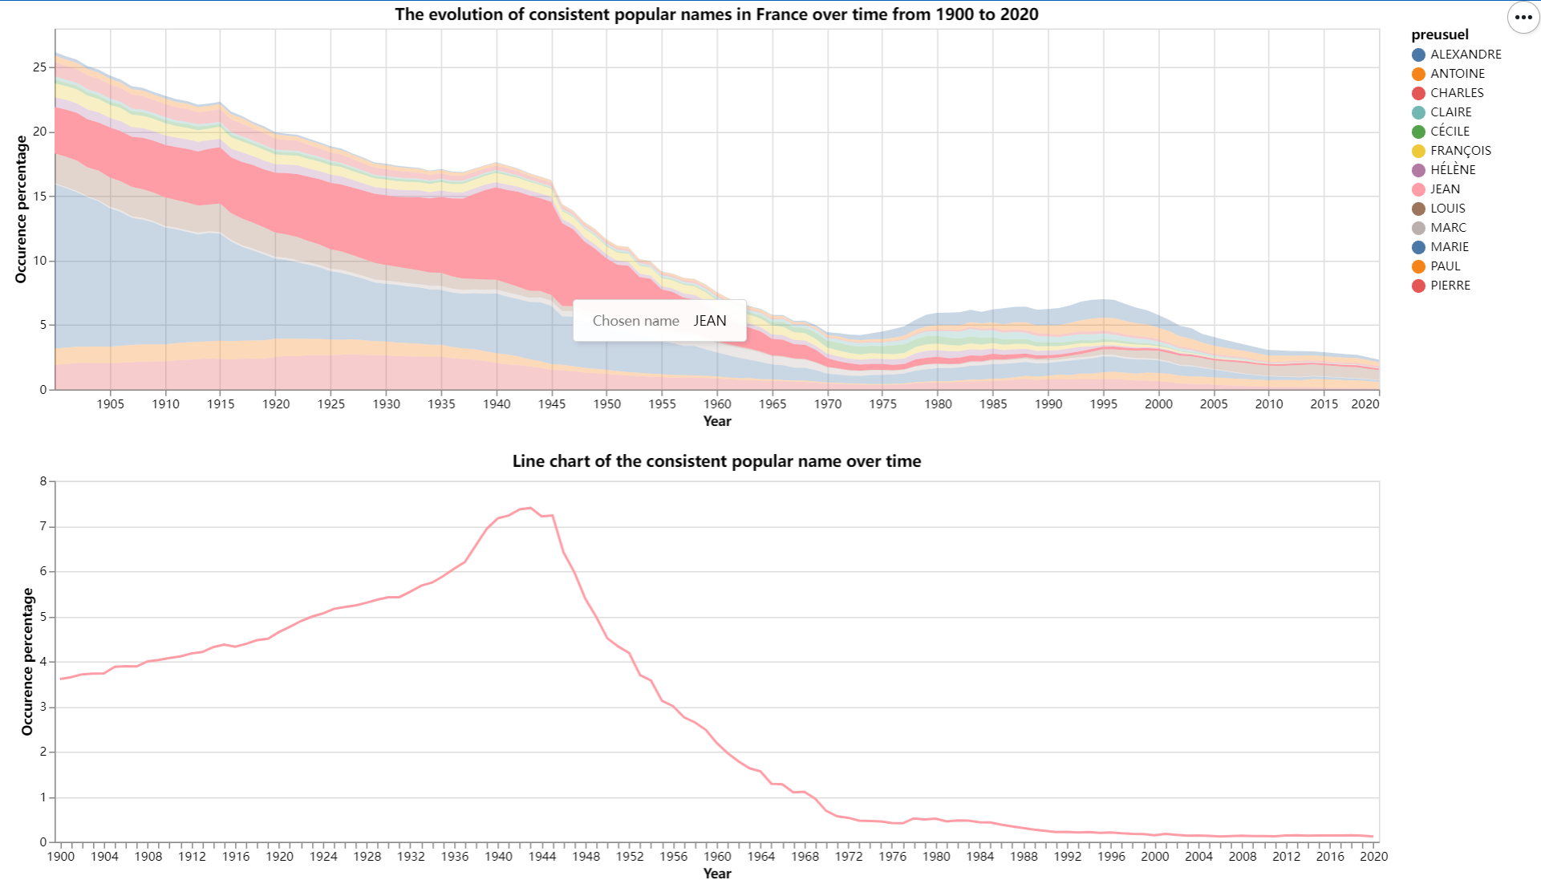
We define the unpopularity in almost the same way: Those names that remains in last bottom_popularity (e.g. 800) in bottom_percentage (e.g. 80%) percent of the year in (min_year, max_year). An example with (800, 80%) is shown below:
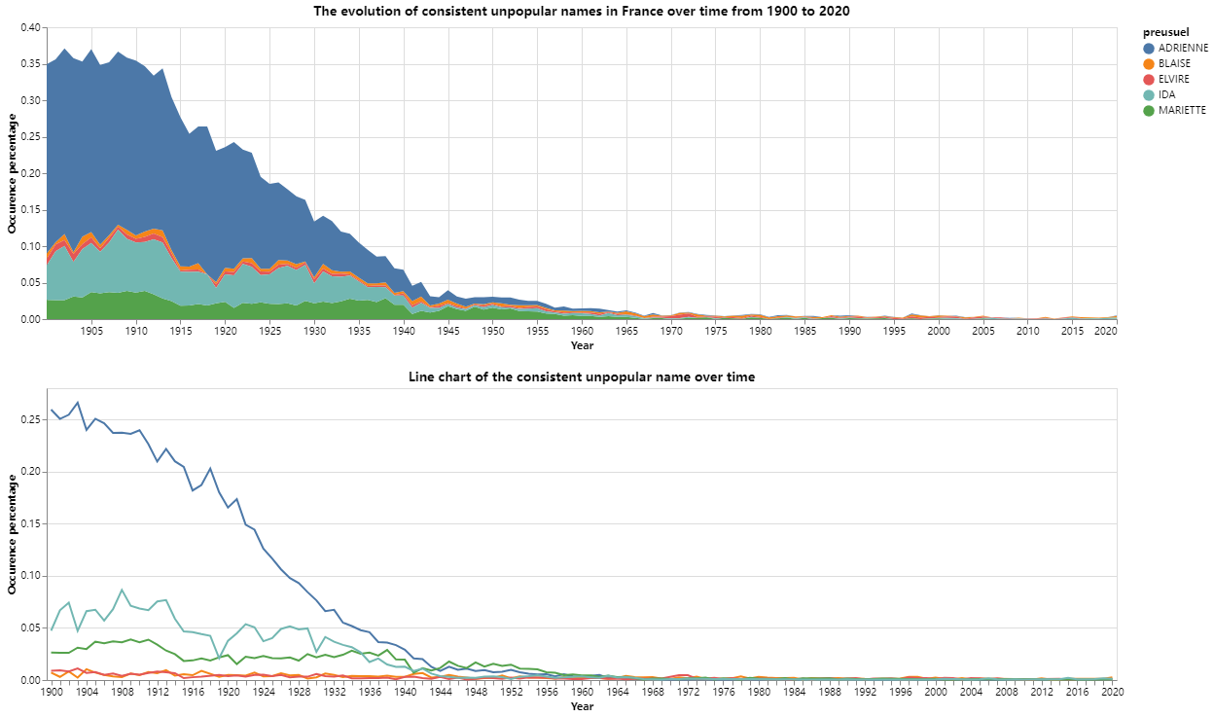
To better see the sudden changes in some names during the time period, we define a new set of filtering parameters: if a name have a sudden switch of rank over sudden_switch (e.g. 3000) and its best rank in one year during this time period is within best_rank (e.g. 20), then we filter them out.
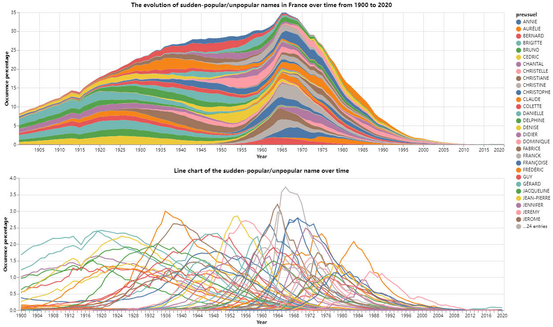
By setting (3000, 20) and changement = True, we obtain the above chart. We could hover on a typical name to see its evolution over time:
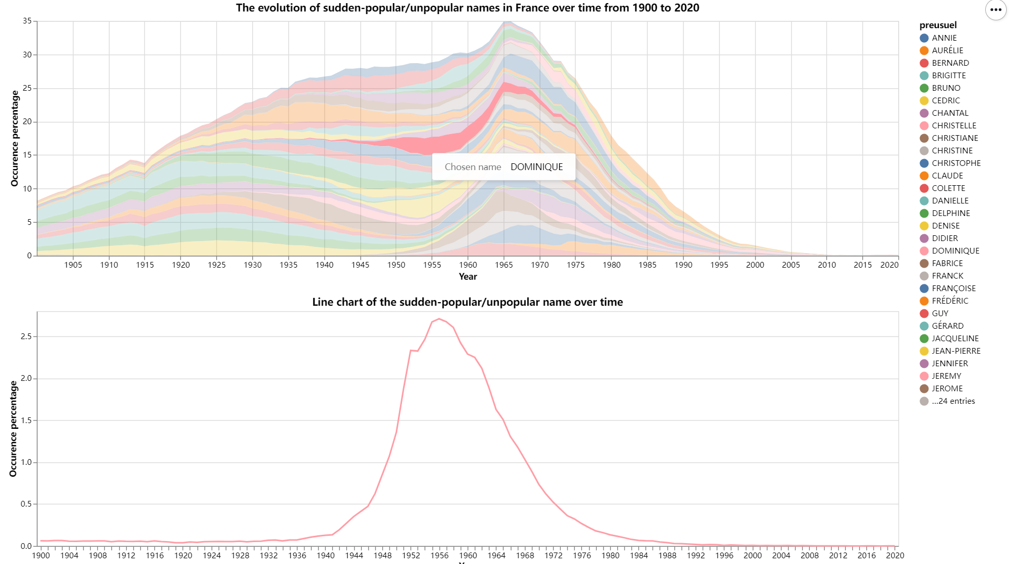
As we can see from the above figure, the sudden switch occurred mostly in 1960-1980, with a almost simultaneous decline fore these names. In this way, we can clearly see the trend in time (the trend for name diversity can also be viewed in previous figures).

Discussion of the Solution's Strengths and Weaknesses
Strengths:
1. Interactivity: The solution includes parameters allowing users to interact with the visualization. Users can select specific time periods and hover over names to see their trends, providing a dynamic way to explore the data.
2. Comprehensive Filtering Options: The ability to filter names by different criteria (e.g., consistent popularity, sudden changes) allows for a detailed analysis of naming trends. This helps users understand not just overall trends but also specific patterns in name popularity.
3. Multiple Visual Representations: The use of three different types of charts (area chart, line chart, bar chart) provides multiple perspectives on the data, making it easier to identify and understand trends over time.
4. Customization: Parameters such as `display_typical_name`, `top_popularity`, `bottom_popularity`, and `sudden_switch` offer flexibility, enabling users to tailor the visualization to their specific needs and definitions of popularity.

Weaknesses:
1. Complexity: The solution’s extensive use of parameters might be overwhelming for users who are not familiar with data visualization techniques.
2. Lack of Interface: The parameters are manually set in code block, it’s not implemented as interactive buttons or text bars for the user to interact with.
3. Limited Contextual Information: The visualization does not provide much context about why certain names become popular or decline. Integrating additional data sources (e.g., historical events, cultural trends) could offer more insights into the reasons behind these trends.

